7 Seals - Revelation 6 |  | Matthew 24
1st Seal  …a white horse!  And its rider had a bow, and a crown was given to him, and he came out conquering, and to conquer. Vs 2  Jesus’ Arrows are  Seal 2, 3 & 4 | 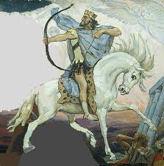  Also Eze 5:14-17; Ps 7:11-13; 45:3-5 | Song of Moses  I will spend my arrows on them;  they shall be wasted with hunger, & devoured by plague & poisonous pestilence; I will send the teeth of beasts against them… Outdoors the sword shall bereave, & indoors terror…  Deut. 32:23-25
2nd Seal  …to take peace from the earth, and that people should kill one another…  Vs 4 | 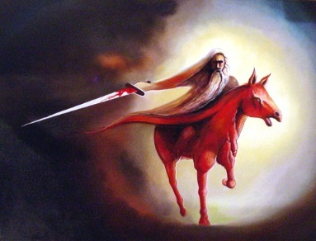 | WAR  …nation will rise against nation…  Vs 7
3rd Seal  Measured barley and wheat for a days wage…& do not harm the oil or wine…  Vs 6 | 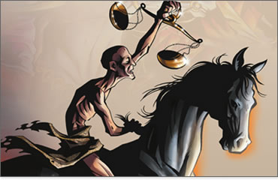 | FAMINES…  Vs 7
4th Seal  Granted to kill 1/4th of earth by:  - Sword  - Hunger  - Deadly Plague  - Beasts Vs 8 | 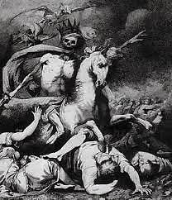 | - Nation vs Nation  - Famine  - Pestilence  - Earthquakes…Vs 7  Beginning of Sorrows…Vs 8
5th Seal  God tells the dead martyrs under the alter to rest because their brothers were going to join them  Vs 9-11 | 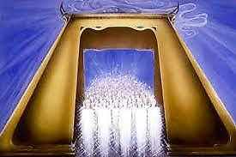 | Then they will deliver you up to tribulation and kill you, and you will be hated by all nations for My name's sake.  Vs 9
6th Seal  …the sun became black as sackcloth of hair, and the moon became like blood. 13 And the stars of heaven fell to the earth,…Vs 12 | 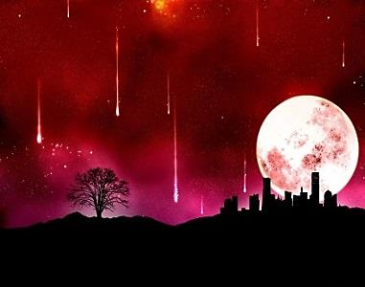 | "Immediately after the tribulation of those days the sun will be darkened, and the moon will not give its light; the stars will fall from heaven…Vs 29
1st Seal  He rode out to win many battles and gain the victory. Vs 2 (NLT 2007) | 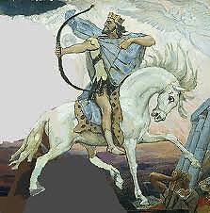 | …they will see the Son of Man coming on the clouds of heaven with power and great glory…  Vs 30  White Horse Returns Rev 19:11-18
7th Seal  …the seven angels who had the seven trumpets prepared themselves to sound…  Rev 8:6 |  | …He will send His angels with a great sound of a trumpet, & they will gather together His elect from the four winds…Vs 31  1Cor15:52- “Last Trumpet”  1Thes 4:17

